谭树杰 11849060

Lab6 Report

1. Use a homomorphic filter to enhance bridge.pgm and

goldhill.pgm filter

The picture shown below is the bridge.pgm and goldhill.pgm and their processed image with = (2,0.25),(2,0.5),(2,0.75),(1.5，0.75), (3,0.75) respectively. ( c = 1 and D0 = 200)

**图片包含 户外, 树, 草, 火车

已生成极高可信度的说明** 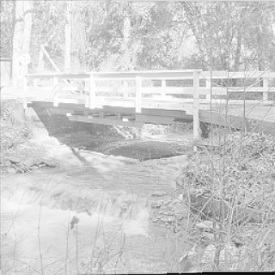 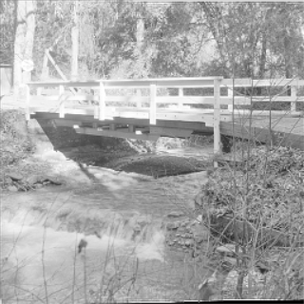

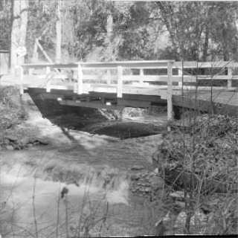 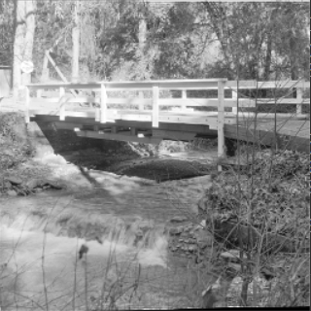 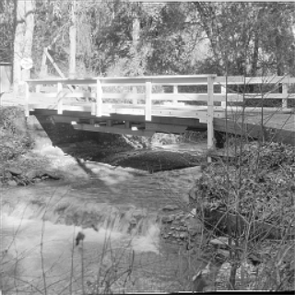

图片包含 户外, 天空, 建筑物, 树

已生成极高可信度的说明 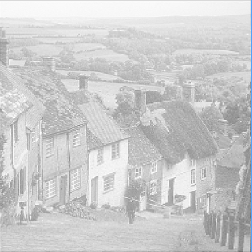 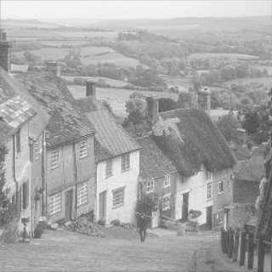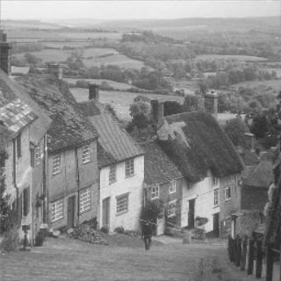 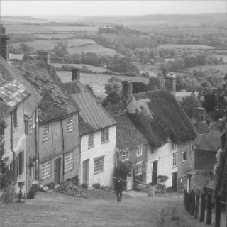 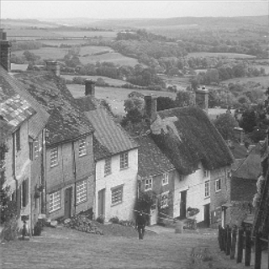

Analysis:

If the parameters , the filter function tends to attenuate the contribution made by the low frequencies(illumination) and amplify the contribution made by high frequencies(reflectance). As we can see in above images, we get simultaneous dynamic range compression and contrast enhancement of the image when we choose appropriate parametes.

The implementation by C++ and opencv is shown below:





1. Add sinusoidal noise to lena.pgm and use bandreject filter to recover lena.pgm

The lena.pgm, lena.jpg with sinusoidal noise and its magnitude spectrum,recovered image using bandreject filter are shown below respectively.

Analysis: We can observe that there a conjugate pair of strong signals in the spectrum, which represent the noise. We can calculate the frequency of the noise by , so I set highcut = 120, lowcut = 110 in bandreject filter. The image was improved significantly after filtering. There are a little distortion in the result image, for that we filtered some frequencies of the origin lena.pgm image.

图片包含 人员, 妇女, 户外, 服装

已生成极高可信度的说明 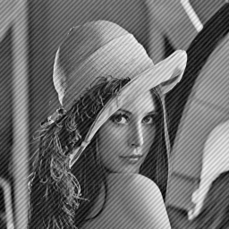 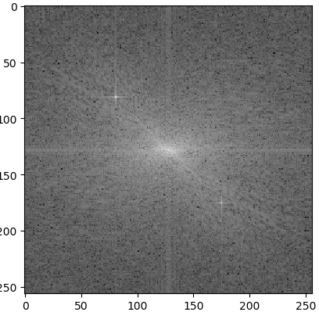 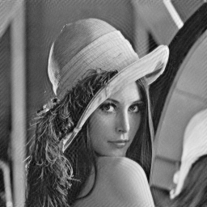

The implementation by python is shown below:





1. Use your cell phone to take three images : one image of your face as template, one large image with your face, and another large image without your face. Use correlation and the template to determine which of the later two images contains your face (note, the face template may not be same as the one in the image)

**The template image, image without my face, image with my face are shown below:**

图片包含 人员, 墙壁, 领带, 服装

已生成极高可信度的说明 **图片包含 窗帘, 室内, 墙壁, 地板

已生成极高可信度的说明** 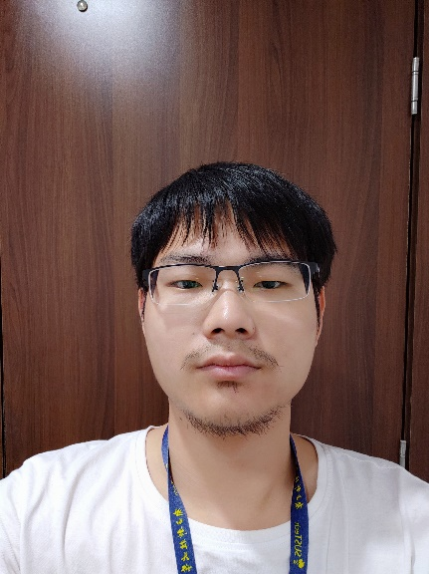

**Analysis: We calculated that max correlation of face.jpg and template.jpg is 266244065.0 and max correlation of noface.jpg and template.jpg is266244065.0, so face.jpg has my face, as desired.**

**The implementation by python is shown below:**

